# Report for Theodore Keller (2024-10-01 to 2024-10-31)

Average Bat Speed: 42.87

Average Rotational Acceleration: 4.40

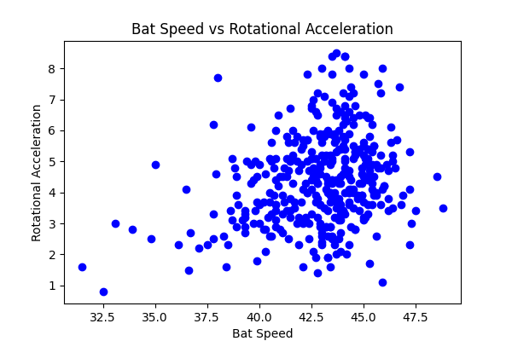

## Comments

Add comments here...